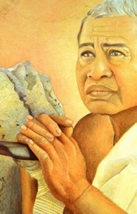
LANAKILA PARK ~
tribute TO ELIZABETH
LANAKILA DOWSETT PARKER
WAIMEA, HAWAI’I

MALAMA HONUA ~
Essence OF THE
WORLDWIDE VOYAGE in Glass

NOVEMBER 2014
Calley O’Neill

I have happily lived in Waimea with my two children, Leianna and Noa for 24 years. Every year, my love for Waimea deepens and grows. Every day I am more grateful and inspired.

As a leading edge conservation artist, social ecologist, visionary landscape designer, mother and teacher, my passion is to make a difference in Hawai’i through working locally. For decades I have worked toward the integration of my skills and experience in public art and ecology with the intention of having a major positive impact where I live. My life’s work is to help create a future for Hawai’i that is better than we can imagine! Toward this goal, I am continually visualizing how public places can be transformed to vibrant people places reflecting the potential for an abundant, sustainable, vibrant, healthy future.

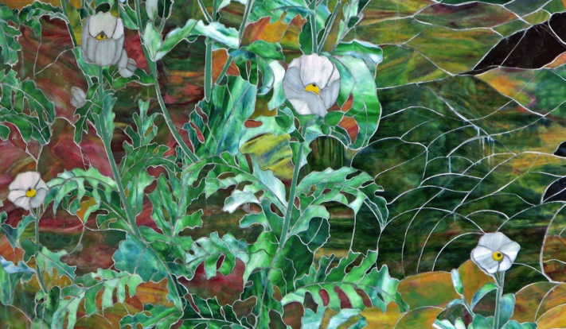

Detail, hand crafted stained glass exterior mural: Puakala (Native Hawaiian Poppy) at Puakea Bay

Since I first became aware of MALAMA HONUA ~ THE WORLDWIDE VOYAGE (WWV), it has been constantly on my mind, swirling in my imagination. I have felt irresistibly compelled to create an iconic community mural in Waimea amplifying the message of this epic journey, MALAMA HONUA ~ TAKE CARE OF OUR EARTH!

Imagine the beauty of the late Lt. Colonel Lacy Veach’s fleeting vision in 1992 of Hawai’i and the Earth from the Space Shuttle Columbia. That glimpse sparked her life-changing realization that our Earth is an island in space; “Infinitely beautiful. Infinitely fragile.” This moved her to call her friend, navigator Nainoa Thompson from space, to urge him to create a Hokule’a voyage traveling around the Earth to teach the children and inspire the people to MALAMA HONUA – Care for our Mother Earth. This is a clarion call for our future.

After months of looking at potential mural walls in Waimea, during a discussion on the MALAMA HONUA mural with my mosaic partner, he emphasized that I need not find the perfect wall. We could build a freestanding wall, a simple undertaking.

At that moment, the powerful vision that came is what every artist lives for! For years, I had been curious about the beautiful yet empty place at the center of our town ~ Lanakila Park. Recently, I kept wondering how this vacant little treasure might come to life. Passing by Lanakila Park, I spontaneously envisioned the park transformed by a magnificent iconic stained glass mural, connected to a ‘green’ halau (replacing the existing gazebo), expressing the call of THE WORLDWIDE VOYAGE ~ that we must awaken to what is happening to life on Earth and why it’s essential to preserve it.

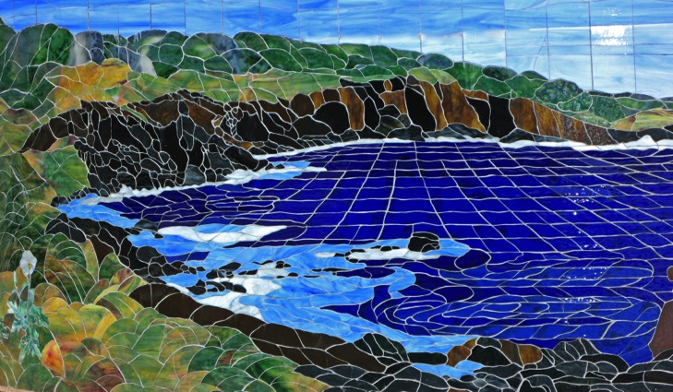

Center detail: Puakala at Puakea Bay, curving exterior wall, Puakea Ranch
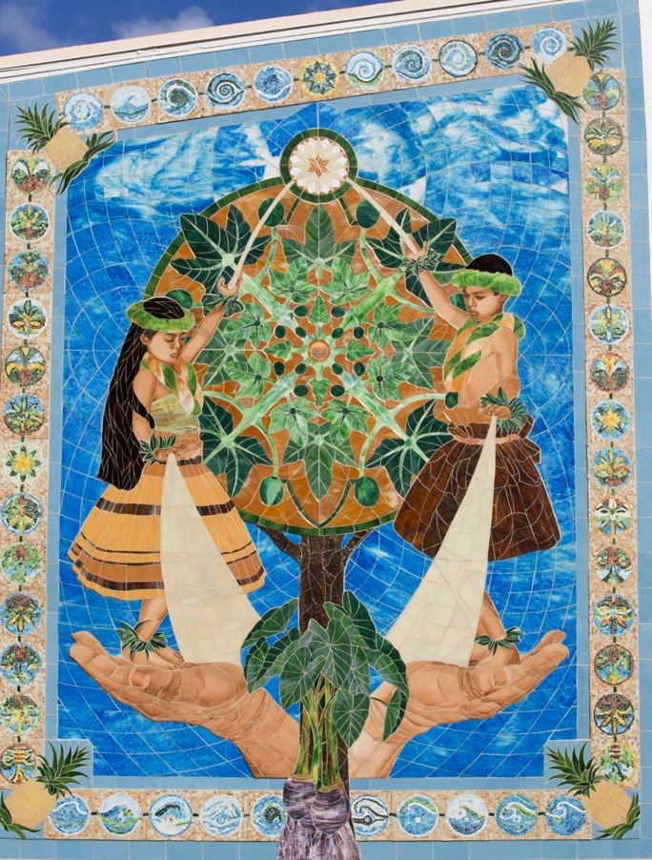

KIPAPA AND THE PATH OF LIGHT, KIPAPA ELEMENTARY SCHOOL Hawai’i’s first stained glass mural by CALLEY O’NEILL 2014
Significantly, the MALAMA HONUA mural idea was also inspired by my recent public art experience at Kipapa Elementary School on O`ahu. I worked with over 115 4th graders and more than 60 local adult volunteers from the principal, to the lead custodian, to grandparents, parents, and political leaders who all became totally immersed in creating the intricate mosaic mural border. KIPAPA AND THE PATH OF LIGHT, my first Hawai’i State Foundation on Culture and the Arts, Art in Public Places commission attracted over 200 people here, and on Oahu to work together. KIPAPA AND THE PATH OF LIGHT has already become a cherished landmark that people travel to experience Hawai’i’s first stained glass mural. With 18,000 pieces of handcrafted smalti in the border, 3,000 pieces of exquisite handmade glass, artist-designed fused golds and hand-painted, fired detailing on the figures, KIPAPA AND THE PATH OF LIGHT is an uplifting experience of ever changing light and color, meaning, and kaona (depth of meaning).

Opening the mural dedication, area superintendent Dr. John Brummell told of a recent district meeting of school leaders at Kipapa: “Try as I might to direct their focus to other issues, the only thing they wanted to talk about was - the mural!’ Everyday, this mural is lighting up the school, inspiring the children, staff, and the community. http://www.CalleyONeill.com/KipapaMural.html

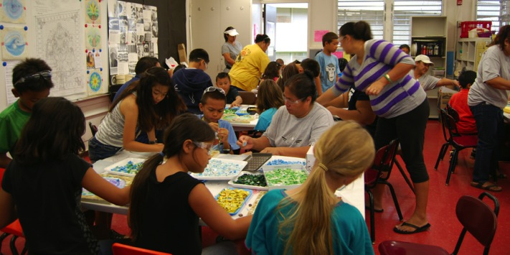
Immersed in their work, Kipapa 4th graders and a diverse group of adults concentrate on work on the border.

RATIONALE: Given extreme loss of biodiversity, serious climate and ocean changes, reef degradation, and the fragile state of nature in global island ecosystems, and Hawai’i in particular, it is crucial for us to accelerate our work in recreating a life in harmony with nature. It is art, not information, to which the most powerful part of us responds. Throughout time, it was art that moved people into new levels of awareness and the action needed to evolve a robust society and create a healthy future. Our actions will determine the quality of life on Earth for the foreseeable future. Now, we all must become konohiki (skillful stewards) once again ~ on behalf of our infinitely beautiful, infinitely fragile home, which will nurture our children’s children’s children when we are not here.

WAIMEA: LOVE WHERE YOU LIVE! Given our immense collective wisdom and experience, Waimea is already at the leading edge of the Hawaiian renaissance, local food production, and deserves to evolve to the leading edge of innovative sustainability, renewable energy, community resilience and vitality. The park can help our people connect to each other and the land, while attracting visitors to support local businesses. This park will give us a place to express our love of where we live.

Imagine the Lanakila Park gazebo transformed into a halau for cultural, historical, and ecological education and spiritual renewal. Imagine a beautiful place to sit, pause, and contemplate ever-changing light upon the mosaic. Lanakila Park can be a magnetic, happy place where we can gather to create a pono community ife.

PROJECT synopsis: Currently, Lanakila Park is a highly underutilized place. With the integration of a permanent mosaic mural, halau, wa’a border garden, and gathering place retaining open space, Lanakila Park will become a lively tribute to Elizabeth Parker, indigenous wisdom, and our healthy future.

The design process and border will engage hundreds of local children and adults. The detailed design painting will be become a large poster on recycled stock for Hawai’i classrooms and worldwide outreach. Encouraging WWV images in Hawai’i classrooms is first priority in the Waimea Education Hui’s four WWV educational initiatives this year.

This is a park that would state (as some leading green building models do) you must walk or bike here to spend time. The beautiful low-maintenance border will be filled with native, food and cultural plants that build, bind, and sustained the Hawaiian people of old, and still support the wa’a (the canoe, the island, the Earth). Elegant, safe, durable, and impermeable, mosaics last indefinitely with no maintenance.

The new Lanakila Park will honor Elizabeth, Waimea, Mauna Kea, the ocean, and celebrate our potential in a dynamically beautiful way.
May we bring Lanakila Park to la higher octave and a richer life.

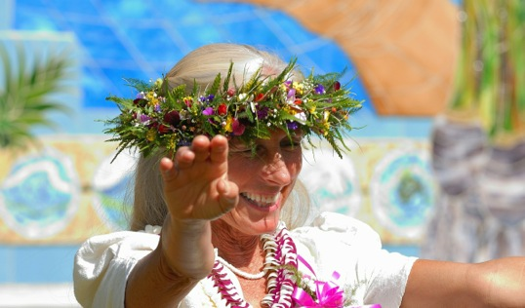
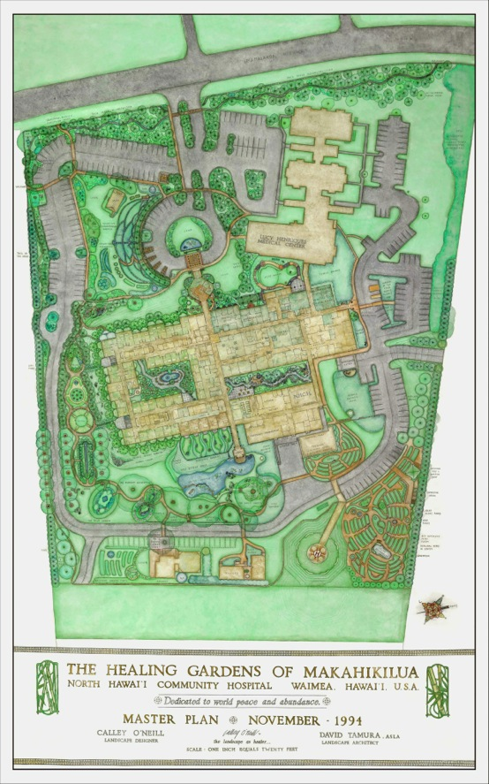

AN EXAMPLE OF CALLEY’S ECOLOGICAL LANDSCAPE DESIGN WORK
MASTER PLAN: THE HEALING GARDENS OF MAKAHIKILUA

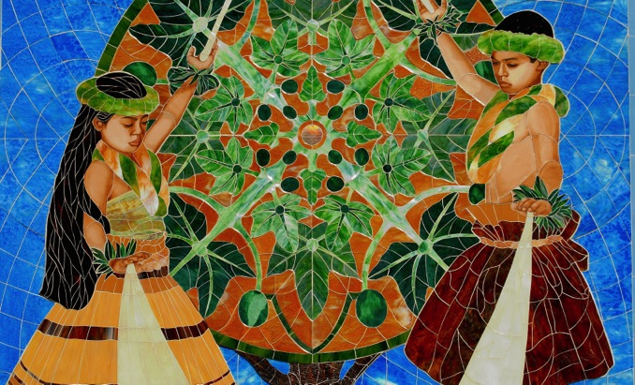

Calley O’Neill (808) 885-0609 THE RAMA TREE, a 501(c)3
CalleyONEILLSTAINEDGLASSANDMOSAIC.COM
Calley@CalleyONeill.com
PO Box 6571 Kamuela, Hawai’i 96743

